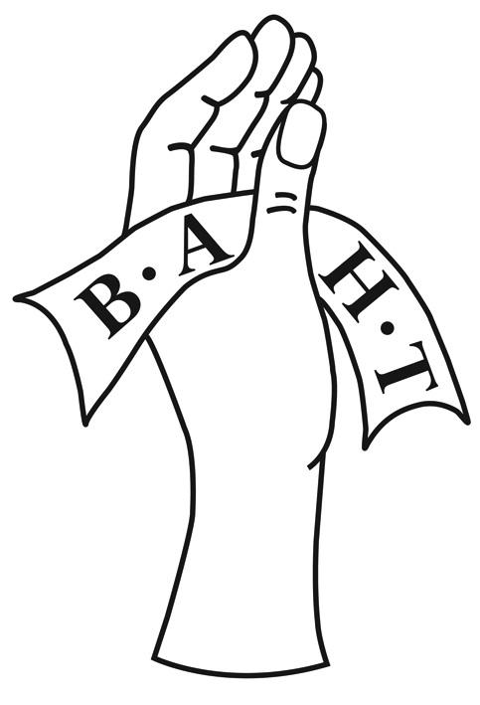

British Association of Hand Therapists

Overseas Sub-Committee Expression of Interest

__________________________________________________________________________

The Overseas Sub-Committee (OSC) of BAHT is a group of qualified occupational therapists and/or physiotherapists who have a special interest in the development of hand therapists and underdeveloped hand therapy services worldwide.
Specifically, individuals in the OSC are elected by the BAHT membership. They will have an interest in promoting education, knowledge and the mentoring of overseas therapists working in Middle and Low income countries. They may already have links with overseas groups / projects but these would not be prioritised. They will give their time voluntarily and each member takes responsibility for a different aspect of the committees' role.
Please complete the details below and submit this form along with a short CV to baht.chair@gmail.com
GDPR: The information that you provide on this form will be stored by BAHT while your application is considered. The information will be shared with members of the BAHT EC and BAHT Overseas/BSSH representative to process your application.
Once your application has been processed and decision made, the form will be deleted and your personal details will not be stored. Any future applications would require submission of a new form.

Name:
Job Title: |  | BAHT Number:
Home Town:

Place of work:
Contact Email:

Please use the drop down below to indicate which committee role you would be interested in:

Chair

Experience and Skills

Please give a brief description of your current work area and experience relevant to the role you are applying for: 100 -200 words

Please give a brief description of any teaching, training, mentoring
or supervision you have done: max 100 words

I confirm that the information contained within this form and any appendices are a true and accurate representation of the individual submitting this expression of interest.

Signed: (print) Date:

