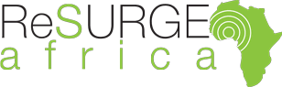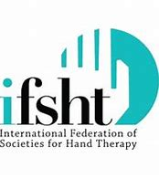

“It was a wonderful course, I was very happy to have learnt more”

“Excellent presentations and work, I really learnt a lot”

“We hope to put all the training into practice. I really learnt a lot”.

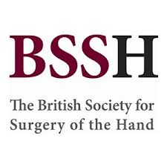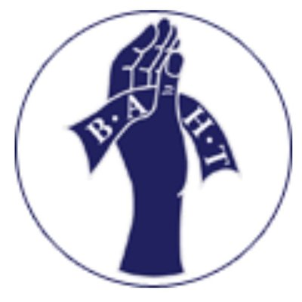
Helping Hands in Sierra Leone
“Knowledge is like a baobab tree: no one person can embrace it with both arms ”African Proverb.
UK Team Members

Mr Ian Grant Consultant Plastic and Reconstruction Surgeon
Mr Steve Hodgson Consultant Orthopaedic Surgeon
Miss Natalie Hope Orthopaedic Surgeon
Kathryn Pank Hand Therapist
Roberta Brincat Hand Therapist Pascalle Smith Hand Therapist

Sierra Leone Team Members
Mr Ismaila Kebbie Lead Physiotherapist Ministry of Health and Sanitation and head therapy at National Rehabilitation Centre. President Sierra Leone Physiotherapy Association
Mr Jesse Banhuah Lead Physiotherapist Connaught Hospital Freetown.
Mr Abu Amara Physiotherapist-in-charge Tonkolili District College of Health Sciences. Lead physiotherapist Sierra Leone China Friendship Hospital at Jui. Secretary Sierra Leone Physiotherapy Association
Mr Balansama Janneh Lead Physiotherapist Holy Spirit Hospital, Makeni
Mr Ansu Kanja Administration Physiotherapy Tonkolili District College of Health Sciences

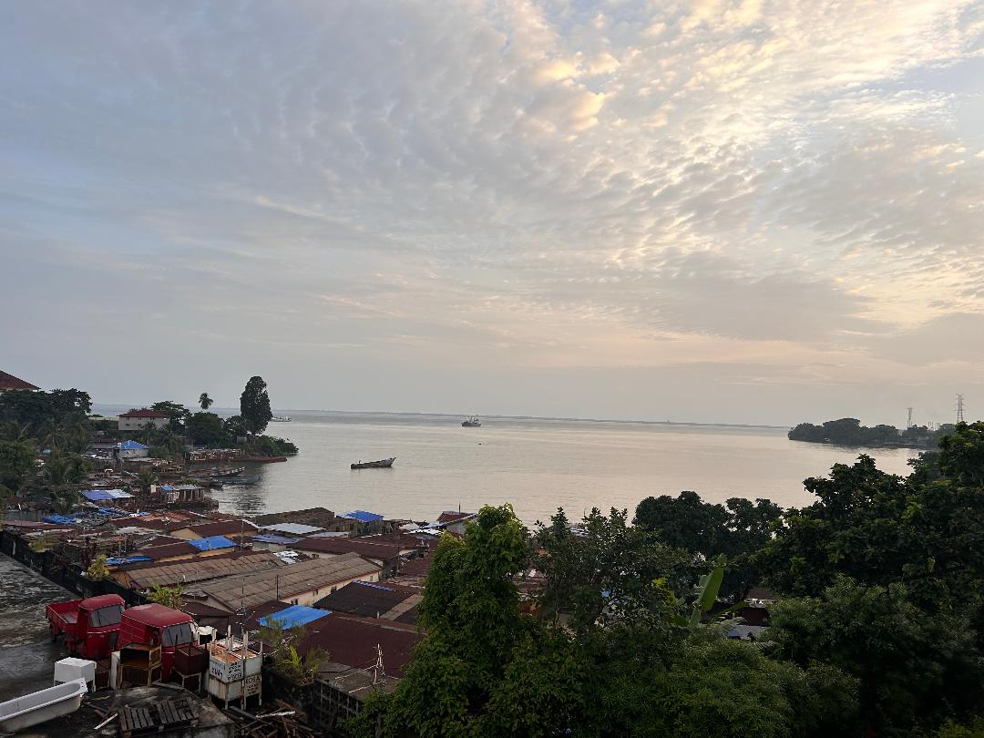
Background
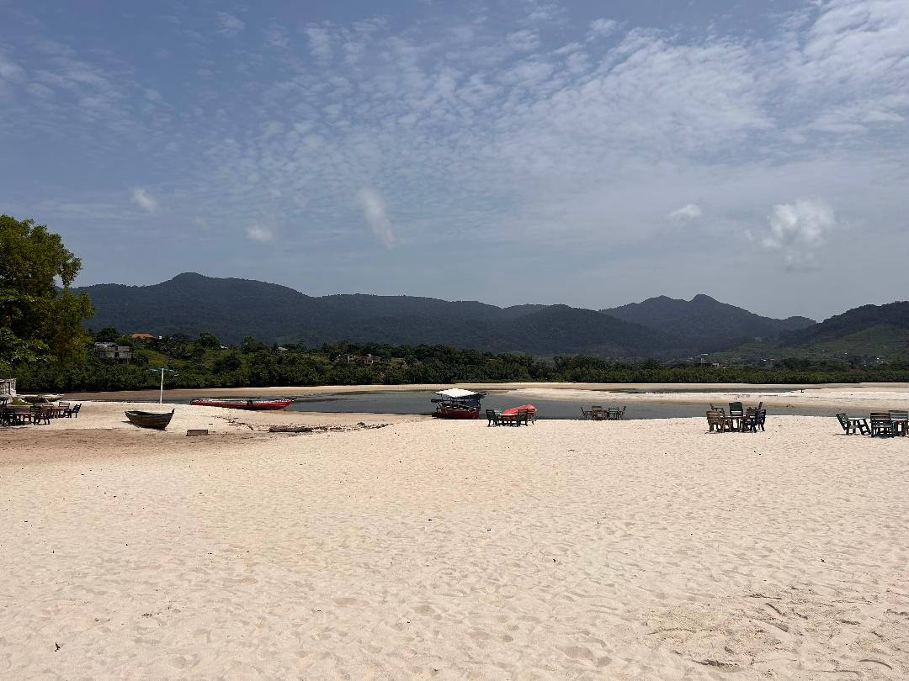
Sierra Leone lies on the coast of West Africa with a population of 7.6 million people. Freetown sits on a coastal peninsula overlooking one of the world’s largest natural harbours. Long stretches of beaches lie beneath a colourful mountainous scenery of greenery, new constructions, and corrugated sheeted shanty towns. It is a country of low income and poverty. 60% of people live under the poverty line. The country has suffered civil war, Ebola and COVID crisis – this, combined with poverty, has weakened the healthcare systems.

Since 2010, The British Society for Surgery of the Hand (BSSH) and ReSurge Africa (NGO) have collaborated to develop the first reconstruction unit in the country at the Holy Spirit Hospital, Makeni. This has included training two local plastic surgeons and a local physiotherapist. Because of civil war and Ebola over the last 10 years there has been a shortage of trained doctors and therapists. In 2019 there were only 7 qualified physios and 1 occupational therapist for the population. Through extensive work by Mr Kebbie and collaboration with Massanga Dk a Danish NGO a 5-year Physiotherapy BSc was started with a cohort of 15 students to improve this. This year a further cohort of 15 students will commence a Diploma in Physiotherapy.

In March 2019, I joined the ongoing BSSH project and assisted on a one-day multidisciplinary introduction course to medical staff, therapists, and nurses on improving care of patients with hand trauma. This teaching visit highlighted that further specialised training was required for therapists in the assessment and treatment of the upper limb.

Aim of the Visit

The aim of our visit in October 2023 was to provide a collaborative two-day Hand Therapy Course. The course covered, anatomy, assessment, oedema management, scar management, principles of splinting, principles of exercise, management of the burnt hand and the deformed stiff hand. This was delivered to qualified physiotherapists and student physiotherapists.

Planning
Pre-visit planning consisted of a UK team WhatsApp group, two team Zoom meetings and email communications. The therapy team met face to face for course workshop/practical planning. All team members received a travel check list produced by Mike Waldrum.
Communication with Sierra Leone therapy leads and UK therapy lead were facilitated by Kings College Partnership which resulted in a productive Zoom meeting with Mr Kebbie, Mr Amara and Mr Janneh.
Pre course BAHT anatomy workbooks were provided to all participants through local leads 3 weeks prior to the visit.

Visit

Landing in Freetown the capital, the new airport is impressive and efficient. The familiar heat, humidity, and smells. The hustle and bustle as crowds of people offer to carry your bags and tout sim cards. From the airport the Sea Bird ferry crossing was uncomfortable in the dark and rather choppy.

Our visit program consisted of two days of teaching at two locations the government run Connaught Hospital, Freetown, and Tonkilili College of Health Sciences in Masanga.

Connaught Hospital Freetown
The first course was held at Connaught Hospital in Freetown. Connaught Hospital is the principal referral hospital and training hospital of Sierra Leonne in Freetown.
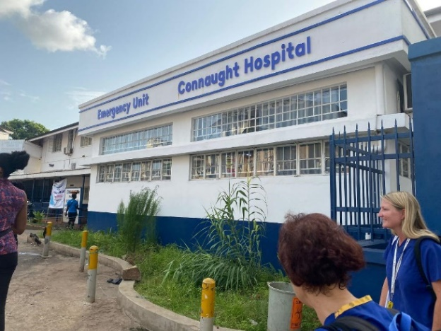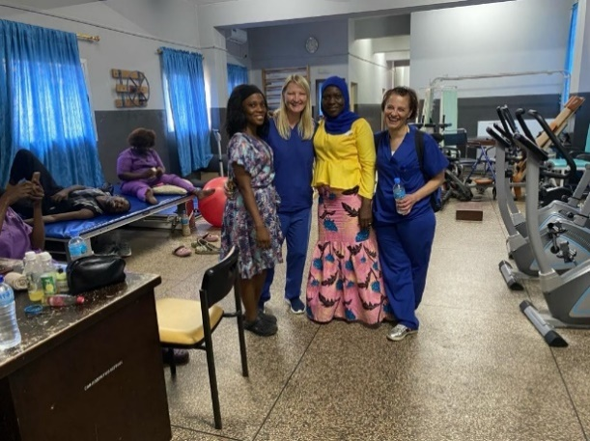

Initial planning indicated that this training would be delivered to the current qualified Physiotherapists. However, only two qualified Physiotherapists and a qualifying physiotherapist student as part of the delegation. The remaining attendees were qualified nurses from trauma and orthopaedic wards. Some of the attendees reported that attendance was compulsory.
On arrival to Connaught Hospital there was a delay of an hour in the start of the programme due to no keys available for the teaching room. The teaching facilities were limited with no additional rooms for the three rotational workshops in the programme.
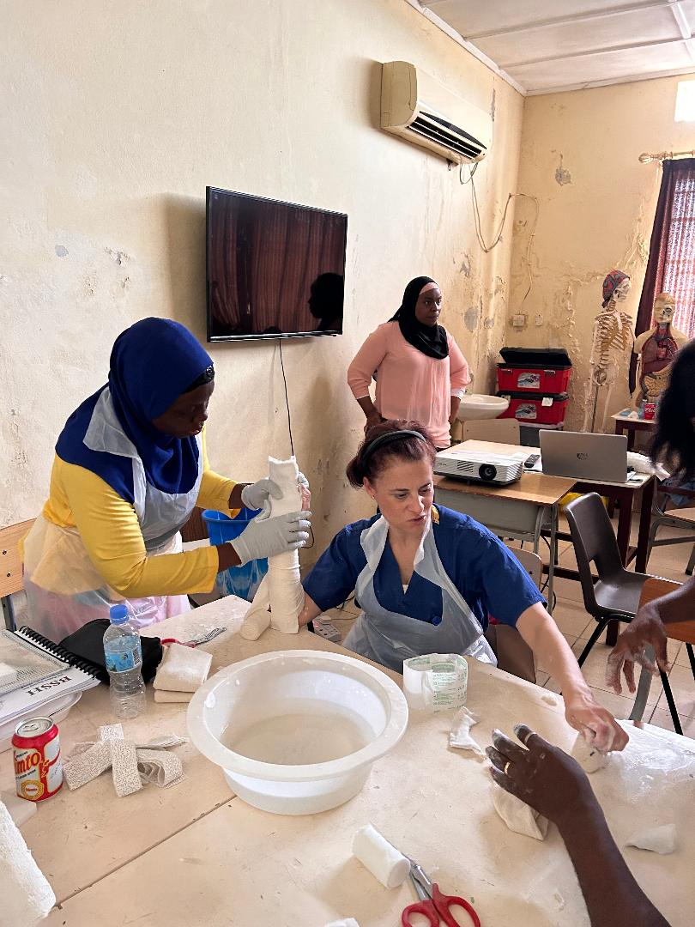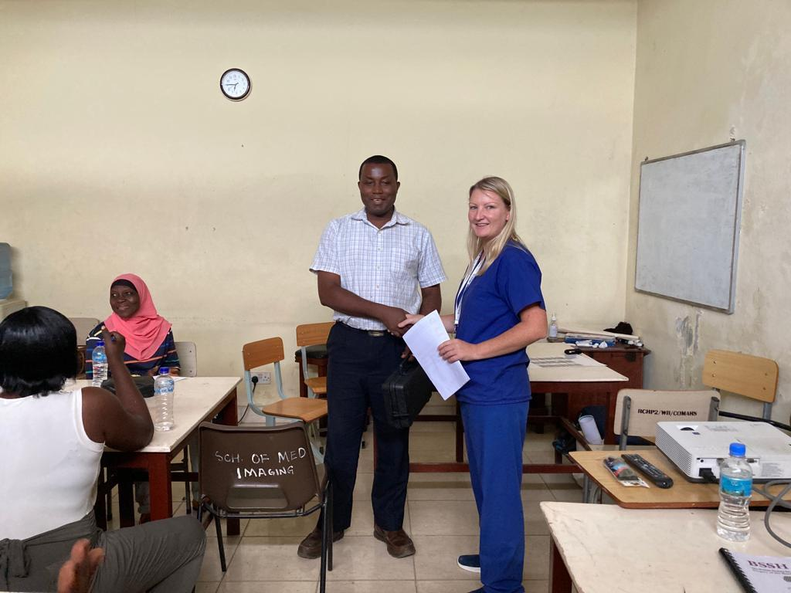
Tonkilili District College of Health Sciences, Masanga
The second venue Tonkillili District College of Health Sciences was three hours east of Freetown at Masanga. The college supports the training of Surgical Community Health Officers, nurses and most recently physiotherapy. The Physiotherapy BSc programme started in 2018 has been developed in support with national and international stakeholders and currently has its first graduating cohort in November 2023 . This will greatly improve the number of qualified physiotherapists of which there are currently only seven in the whole country.
The two-day course was delivered to the 20 physiotherapists qualifying this year. College administration was efficient and good teaching space was available. However, worth noting for future there was no air conditioning, electricity supply was occasionally disrupted, and poor lighting shortened the end of our first day of teaching.

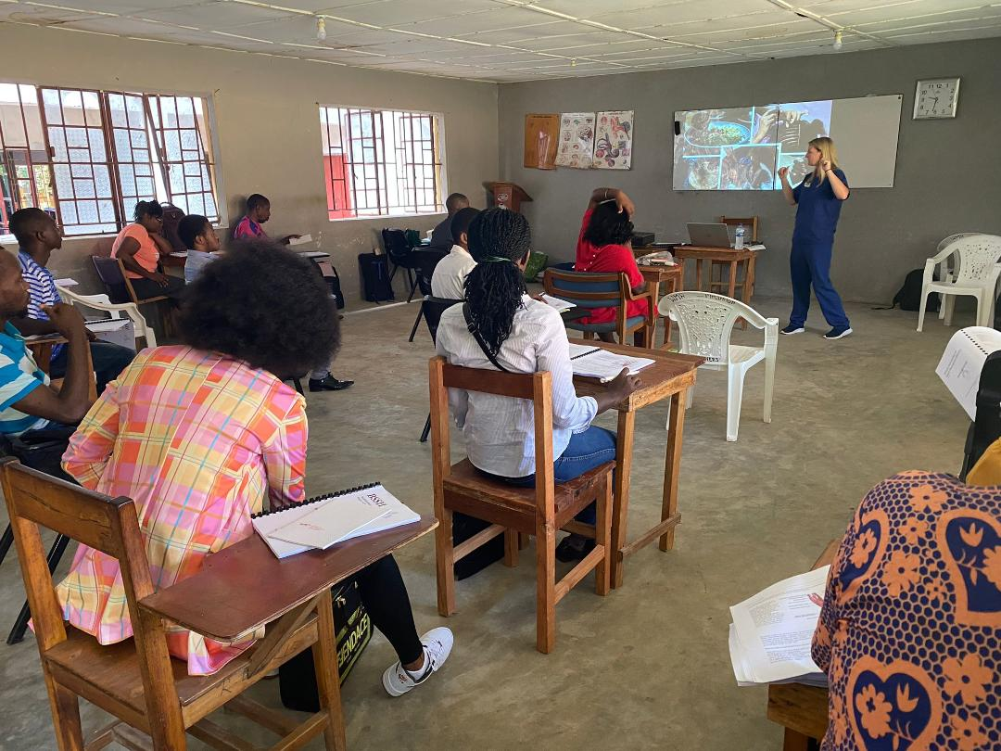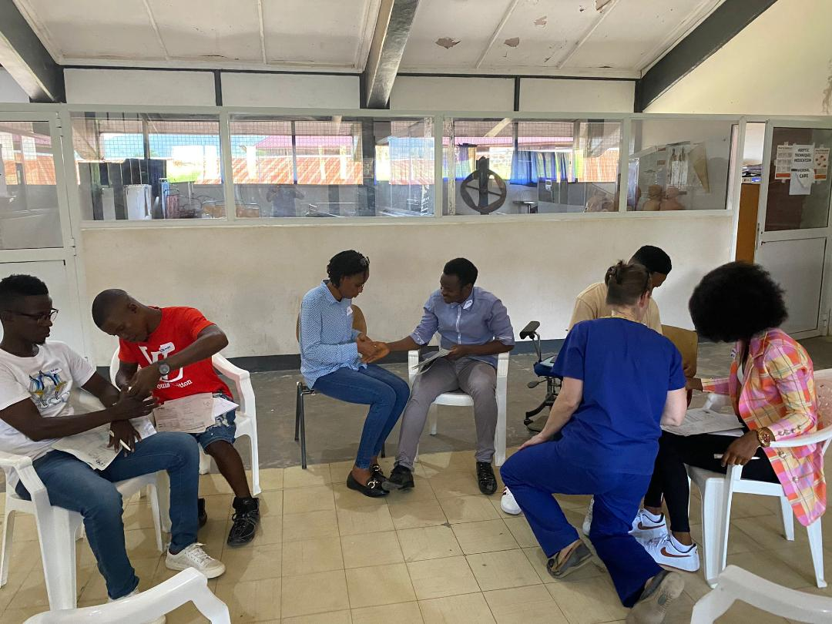

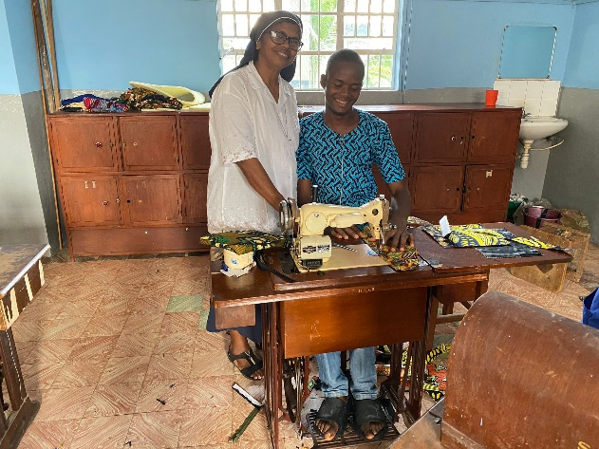
During the teaching at Masanga we used Makeni as a base for our accommodation. We stayed at St Joseph’s School for the Hearing Impaired which has a close relationship with Holy Spirit Hospital in Makeni. We were inspired by the school’s textile workshop which produces clothing, bags, and souvenirs for tourists.

Holy Spirit Hospital, Makeni
We briefly visited The Holy Spirit Hospital (HSH) in Makeni which was established by Dr Patrick Turay. Through many atrocities in the last decade such as Ebola it has continued to develop and expand with the help of the Italian Diocese and sheer determination. The Holy Spirit Hospital now has 70 beds, an Outpatients Department, x-ray, a Pharmacy and two operating theatres. The physiotherapy department was destroyed by fire in 2018 and now a new development with physiotherapy, pathology labs and additional ward space for surgical visits has been built.
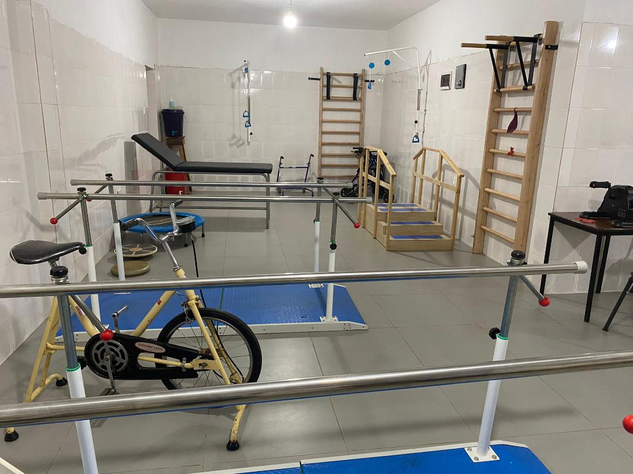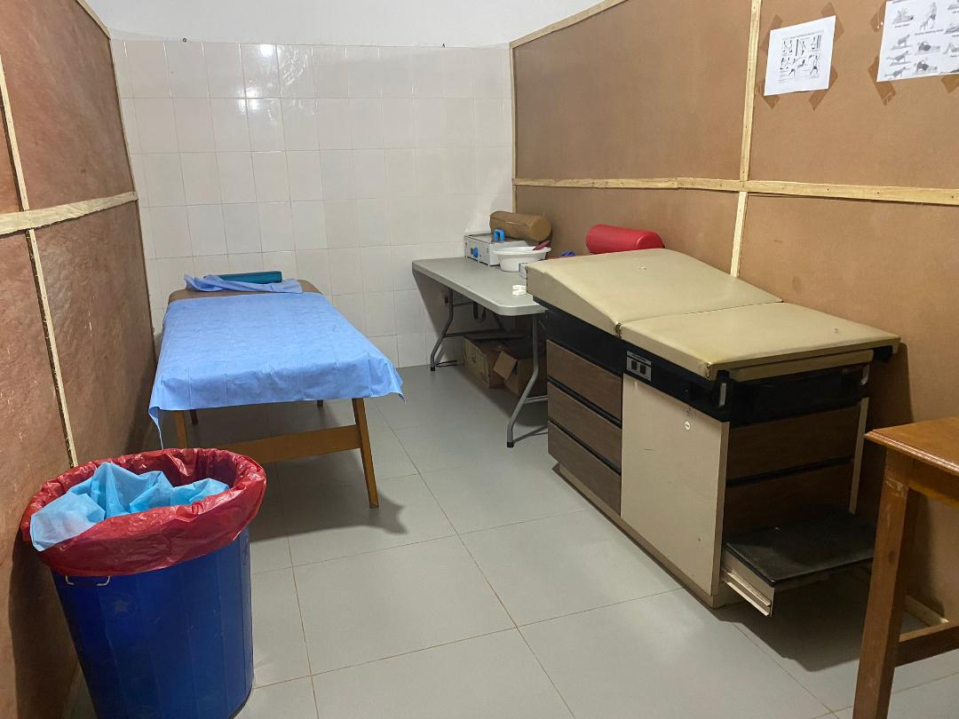

Evaluation
As a short, two-day course, the programme was an introduction to specialist upper limb therapy. Encouraging education and empowering local therapy staff and therapy students to provide future cascade of learning, mentoring and knowledge. This encourages a sustainable project for Sierra Leone to develop health care for the future.
Cultural expectations of catering, time-keeping and physical teaching facilities challenged the team. Local administrative support and assistance helped to overcome this, but future visits must ensure that these issues are taken into consideration.
Each day of our teaching was positively brimming with enthusiasm and a genuine keenness to learn. A Pre and post course quiz showed improvement in scores and knowledge of (Appendix 1 Quiz Analysis). Course evaluation was very positive about the delivery, the content and all participants felt they had benefited from attending. Overall, 87% of attendees rated the course “Very Good” or “Excellent”.
All teaching presentations, worksheets and course workbook were presented to the local clinical and therapy leads on an USB for future use, access, and reference.

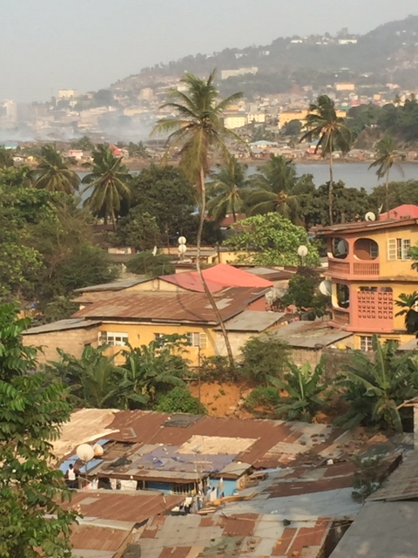
Moving Forward
The visit was very beneficial and successful. Engaging the first Physiotherapy BSc cohort and developing rehabilitation support/knowledge for upper limb surgeries being performed by the newly qualified Plastic Surgeons. We have built on previous connections and widened our network of local partnerships. In the future there is scope to further enhanced collaborative, sustainable education and working in Sierra Leone.
I am very grateful to IFSHT, BSSH, BAHT and ReSurge Africa for making this training programme possible. Thanks also to all the team members involved for their ongoing hard work, support, knowledge and teamwork. ORFIT and The Horder Centre very generously provided teaching materials and splinting equipment for workshops and teaching on the programme.

